System Architecture and Decision Logic
To address the need for clarity regarding the system's architecture, we provide a detailed overview of the data flow, the boundary between deterministic rules and generative AI, and the integrated safety mechanisms.
System Architecture Diagram
The following diagram illustrates the flow of information from user input to the final eligibility report, explicitly delineating the boundaries of the LLM-driven components.
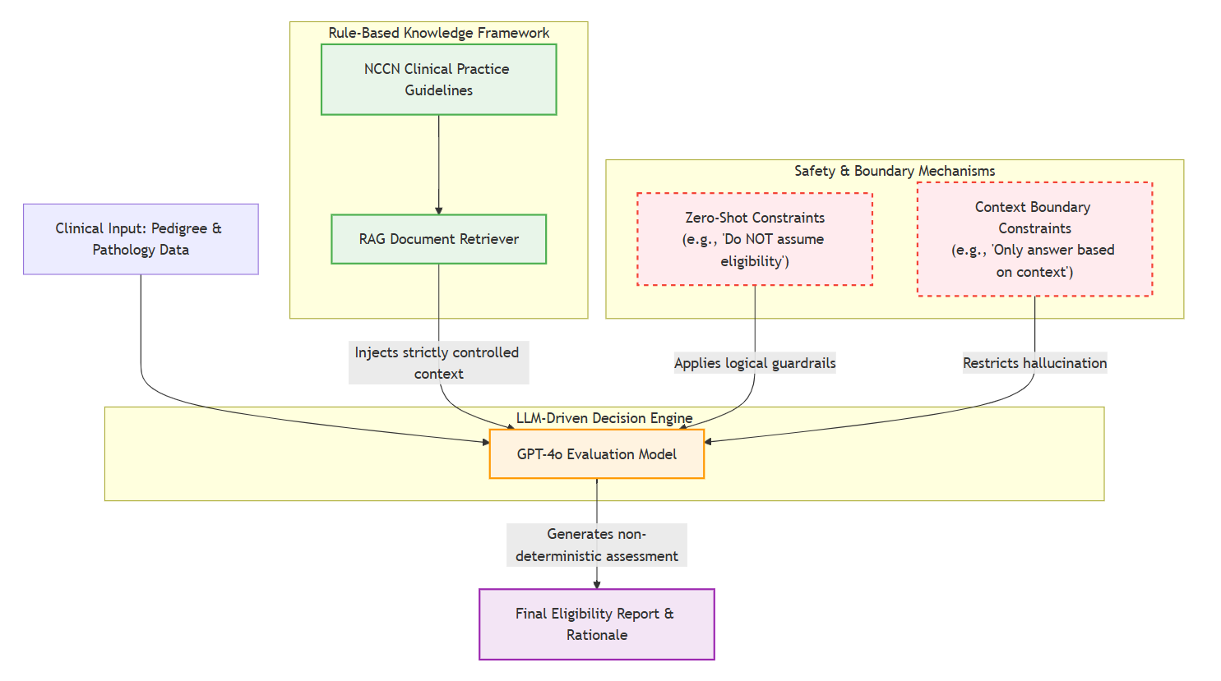
Architectural Description
GeneticBot operates on a hybrid architecture that integrates a static, rule-based knowledge framework with a dynamic, LLM-driven decision engine.
1. The Rule-Based Knowledge Framework
The system relies on the NCCN Clinical Practice Guidelines as its absolute source of truth. The Retrieval-Augmented Generation (RAG) architecture securely loads these guidelines as static reference documents. This component is strictly deterministic; it does not generate information but rather retrieves the exact textual rules required for evaluation.

2. The LLM-Driven Decision Engine
The boundary between rule-based guidelines and AI evaluation occurs at the prompt level. The system does not utilize a deterministic if/else software engine to calculate eligibility. Instead, the raw clinical inputs (pedigree and pathology reports) and the retrieved NCCN rules are passed to the GPT-4o Evaluation Model. The LLM acts as the decision engine, dynamically evaluating the unstructured clinical narrative against the provided rules to determine if the criteria are met. Consequently, the final classification outcome is generative and influenced directly by the LLM's reasoning capabilities.
3. Safety Mechanisms and Hallucination Mitigation
Because the decision engine is generative, the architecture relies heavily on Prompt-Level Safety Mechanisms rather than post-processing software guardrails. To mitigate hallucination and enforce reliability, the system employs:
- Zero-Shot Constraints: The model is explicitly commanded to strictly tether its reasoning to the text. (e.g., "Do NOT assume eligibility unless one or more NCCN criteria are explicitly met").
- Temperature Control: The RAG framework sets the LLM's temperature parameter to 0, effectively neutralizing creative text generation in favor of highly deterministic, reproducible outputs.
- Fail-Safe Defaults: If clinical data (such as a family history) is ambiguous or incomplete, the prompt instructions naturally act as a fail-safe, forcing the LLM to default to an "ineligible" or "insufficient data" classification, thereby safely deferring the final judgment to the human clinician.

